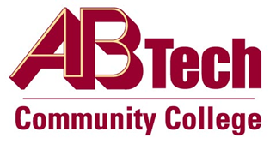

# Asheville-Buncombe Technical Community College

# (A-B Tech) Procedure

## Procedure 506: Service, Retirement Awards, and Memorials Program

## Service Awards

Each year, eligible employees will be notified of their length of service status with the College. The employee will receive a certificate and public acknowledgement during a campus assembly. Depending upon the budget allocated for this purpose, eligible employees may be offered a gift commensurate with their level of service.

## Retirement Awards

Retirement awards are offered to eligible employees reaching retirement at any service level. Upon notification of retirement, the Human Resources department will order a special retirement award to be presented to the retiring employee. Retirement awards may be presented by the immediate supervisor, the President or other method of celebration.

## Memorials of Deceased Employees and Retirees

The A-B Tech Foundation will help coordinate and pay for a recognition plaque memorializing a current and past employee of A-B Tech Community College provided the following criteria are met:

* Recognition is specifically requested by the family or colleagues of the deceased employee or retiree;
* The employee was actively employed or retired from A-B Tech Community College;

Pursuant to Board policy, Chapter 500, Section 506, the Service ,Retirement Awards and Memorials Program procedure must be followed when awarding or recognizing eligible employees.

Owner: Executive Director, Human Resources and Organizational Development

Updated: April 25, 2023